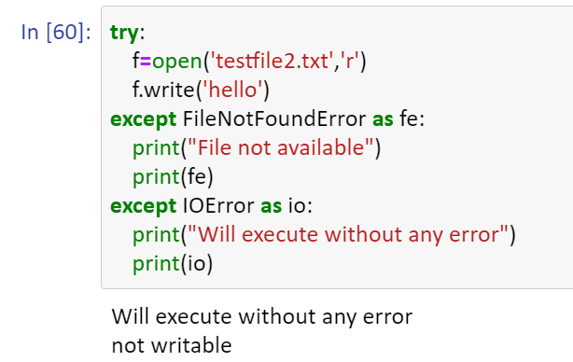

testfile2.txt is imported in ‘r’ format, but trying to write

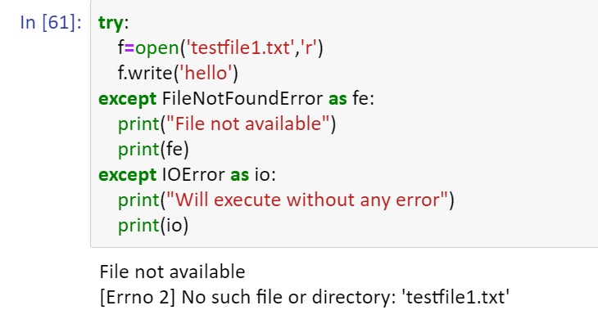

textfile1.txt not available itself­